**Exercise No:11**

**Date:21/11/2020**

**Aim:** Write a Python program to find the greatest common divisor (gcd) of two integers using recursion.

**Program:**

def gcd(a,b):

if(a==0):

return a

if(b==0):

return b

if(a==b):

return b

if(a>b):

return(gcd(a-b,b))

else:

return gcd(a,b-a)

a=int(input("Enter the first number:"))

b=int(input("Enter the second number:"))

GCD=gcd(a,b)

print("GCD is:")

print(GCD)

**Link:**

[**http://103.53.53.18/mod/vpl/forms/edit.php?id=326&userid=1782**](http://103.53.53.18/mod/vpl/forms/edit.php?id=326&userid=1782)

**Output:**

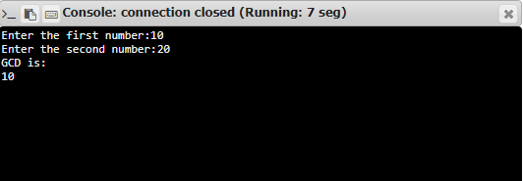

**Result:**

The program was executed successfully and the output was verified.